It’s So Easy – All YOC Members Pay Only $5 to Play Sterling Golf Courses Each Round

**Over 32 courses to choose from. It is $25 registration and only $5.00 per round after that. This is the best golf program for children ages 6-18 ever created.**

**Sterling Golf Management is proud to participate. Check out our courses for times and days available:**

[**www.sterlinggolf.com**](http://www.sterlinggolf.com)



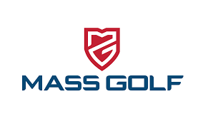

<https://www.massgolf.org/youthoncourse/>

**This page was created for parents and youth to explain how the programs works, the benefits, how to get started and to promote the participating courses**

[**https://www.golfnations.com/mass-golf/?cid=8745**](https://www.golfnations.com/mass-golf/?cid=8745).  
**This is the start page for the registration process.  Upon completion of registration, a confirmation email will be sent to each youth or adult with the youth being assigned a GHIN number (and be able to start posting scores), be required to complete an online curriculum on basic course etiquette, rules of golf, etc.** **and then be able to print out a temporary membership card (which should be presented to your pro shop staff upon check in and before heading to the tee)**

**Youth on Course Program**

**Sign Your Child Up Now!!!**